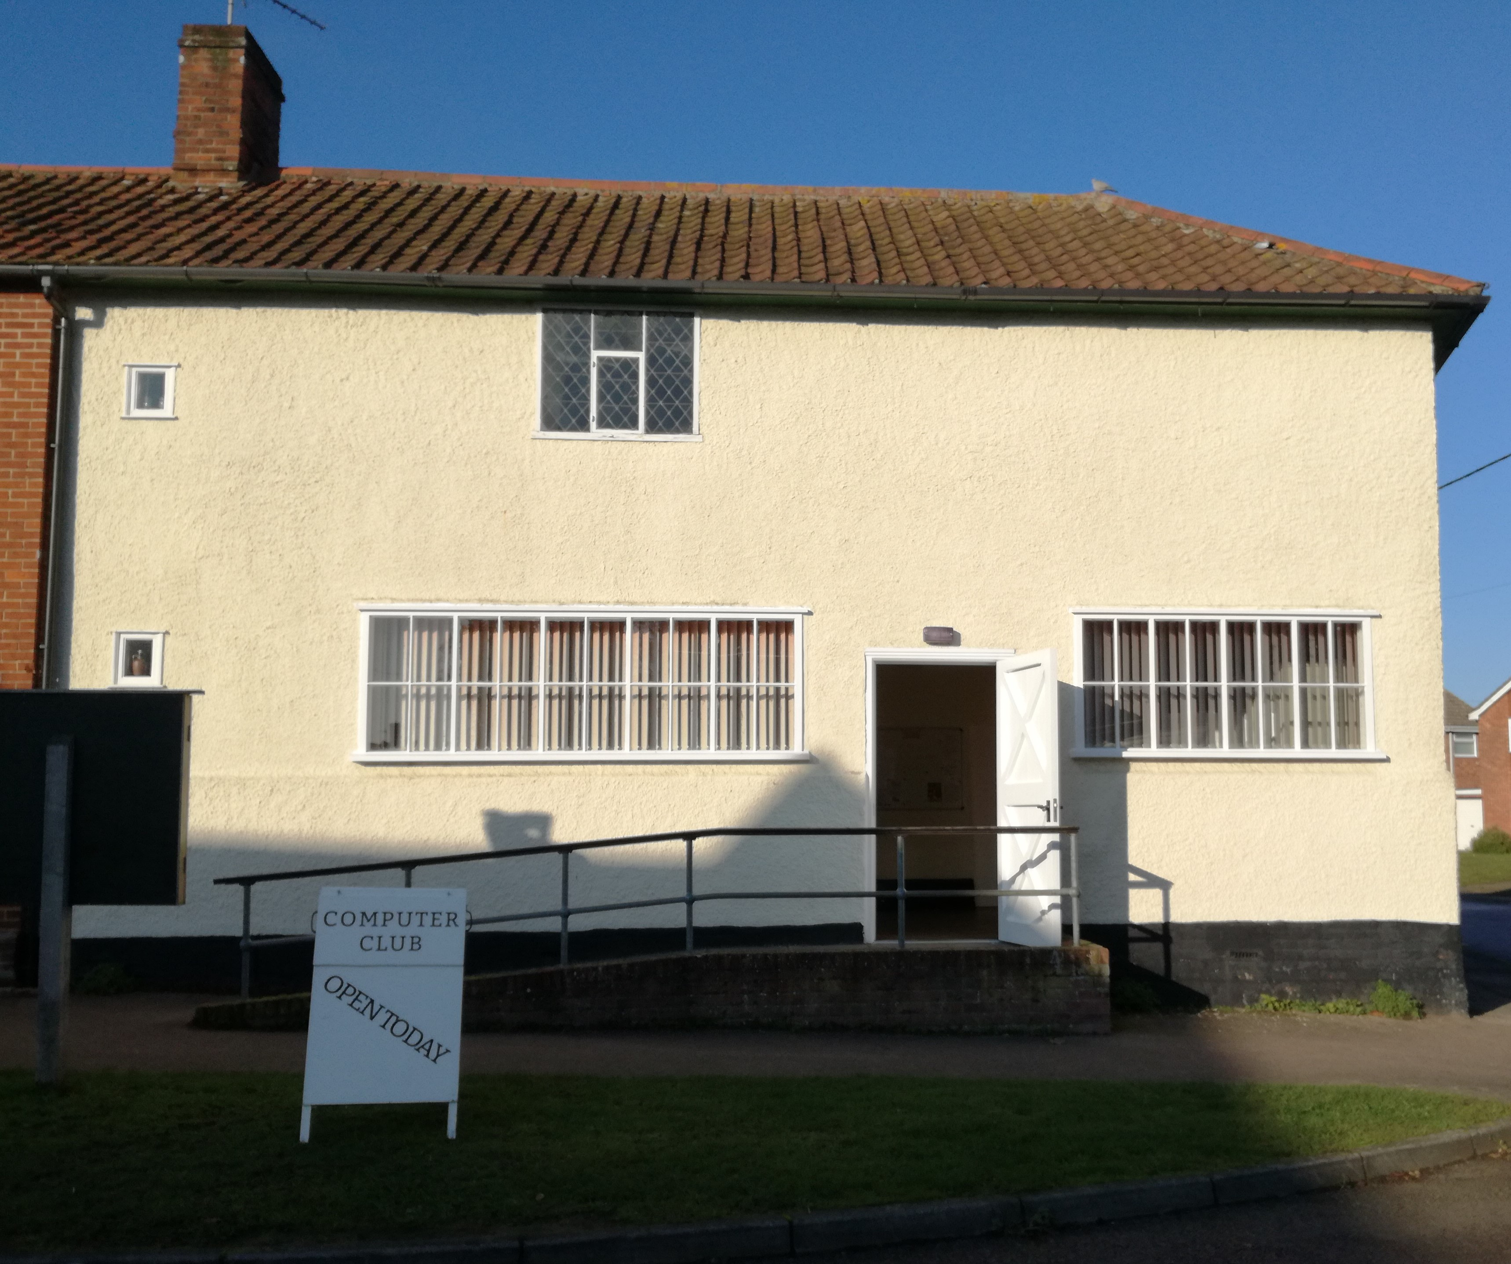
THE OLD SCHOOL ROOM

Home of Mendlesham Computer Club
and
Saturday Café
With our very
best wishes !

To …

From …

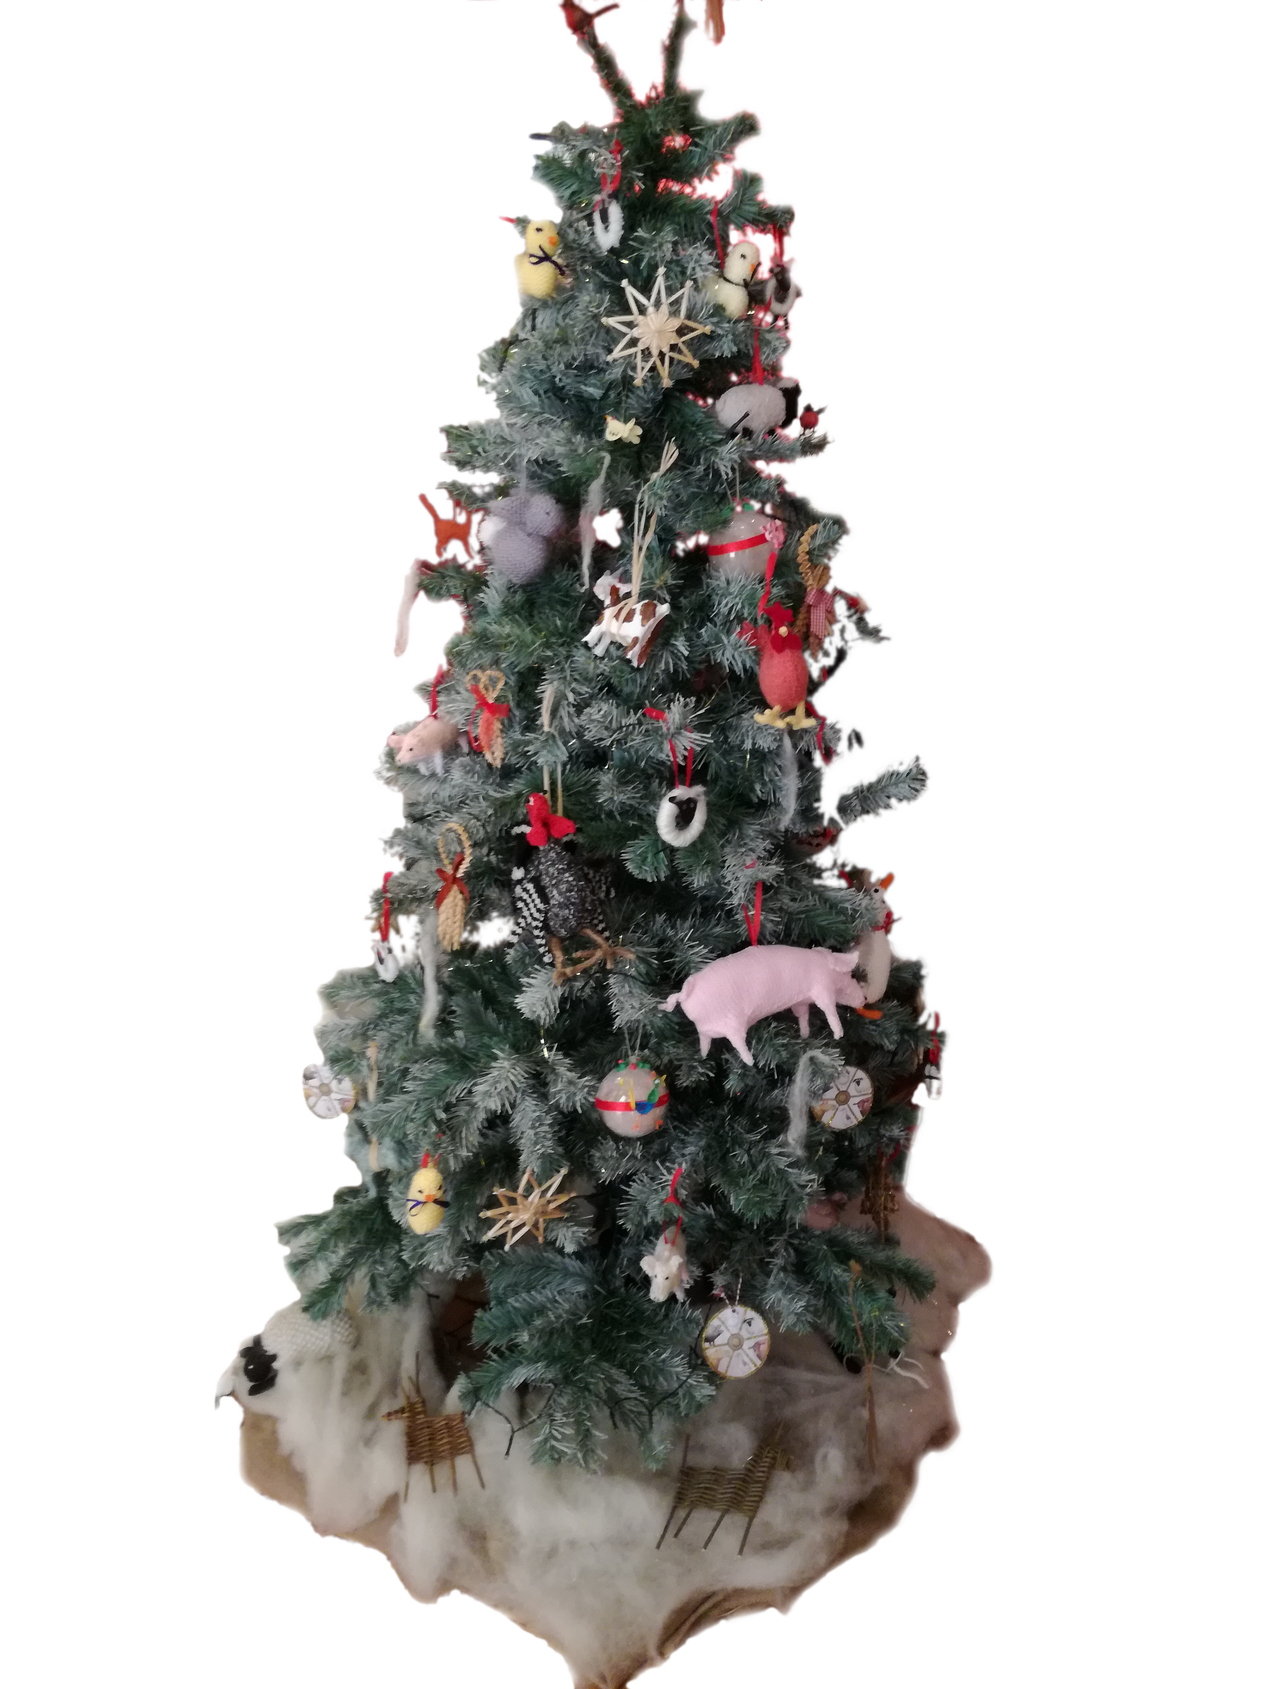

Card designed and produced by Mendlesham Computer Club

Front cover Christmas Tree decorated by
Mendlesham Women's Institute
^{MERRY}
^{CHRISTMAS !!}

